**Faith Jebichii Rutto – Student, Moi University, Kenya.**

**'THE FIELD OF THE ‘PHOTOGRAPHABLE’**

**TOPIC: WORK IN IMAGES AND IMAGES OF WORK**

The first anthropologists, Gregory Bateson and Margaret Mead started using cameras to film in cultural studies to document life in the 1940s. This is the time when visual anthropology spread widely. Over time, photography has been used in research all over the world although very little has been done in Africa especially in tea plantations. Research on tea plantations are sometimes not very accessible because of the set structures by the management. One of the well-known approaches to participatory photography is photovoice, popularized by Wang and Burris (1997) as a participation action research tool, which uses participants' photographs as a catalyst to engage participants and policy-makers in group dialogue for social change (Wang, 2005, in Castleden et al., 2008). The approach draws heavily on Freirian critical education and feminist theory, as well as work on documentary photography and the use of storytelling through photographs (Wang, 2000). It aims at enabling people to record and reflect on their community's strengths and concerns. It also promote critical dialogue and knowledge about community issues through group discussions of photographs; and to reach policymakers (Ho et al., 2010).

Visual anthropology is important as it captures the attention of the reader, tells a story as well as it conveys a message as it is. Photographs aid in capturing what someone or soothing looked like at a particular time. Photographs of work account for the social realities, it gives great insights that bring observational research to its full potential. Images can be used to identify the position of the researcher using both the insider and outsider approaches in social science research. It is also important to review the differences between the emic and epic approaches using the visual art in the field of anthropology. Researchers can decide which angle their work takes based on the kind of images they choose to show.

As a Master of Arts student of Medical Anthropology (Moi University) currently researching on the topic, “*The Effects Of Working Conditions On Health Among Tea Workers In Nandi Tea Estates*”, photography in the research is of key importance. This is in the sense that photographs show the realities as they are without manipulation. Photography is a way of gaining insight into the photographer’s or the researcher’s interpretation of the image depicting work. It is useful in communicating ideas and concepts through images. In my area of research, I employed photography in order to bring out visual realities on the working conditions that the tea workers face. This is because photography is one of the best tools to communicate the research, capture the reader’s attention. It is a system of communication between research data, researcher, and research community. It contains very rich and clear data that could not have been obtained through just words. This includes the nature of work, housing, and sanitation as well as the nutritional aspects. The images also depict how these conditions affect their health and their coping strategies. The design for this research is descriptive. The data collection methods include observation in which I intend to use pictures to describe realities concerning tea workers in Nandi Hills. The study, based on accrued findings will recommend ways on how the employers and the workers can improve the working conditions in Nandi Tea Zones.

**Introduction**

My name is Faith Jebichii Rutto, a final year student of Master of Arts in Medical Anthropology. I have a background in Sociology, Gender and Development Studies from Kenyatta University. Having been born and raised in Nandi Hills, my mornings were characterized by tea workers picking tea early in the morning to late evening. Being a Medical Anthropology student, my interest was to look at the health of the tea workers in relation to their working conditions. Additionally, I was interested in researching about how they cope with the health challenges from their work.

I used was the photographic approach to represent this research without any bias as well as to stimulate real connection to the research. Moreover, photography is useful for interpretation and analysis of data. Findings from the study showed that the nature of work among the Nandi Tea workers predisposes them to illnesses such as back pain, sore arms, headache, and shoulder pain among others. From the research, workers cope with these challenges mainly through self-medication and only seek healthcare when the condition is severe.

One of the challenges I faced during data collection was difficulty in finding time with workers away from the plantation. This is because workers spend up to about 12 hours plucking tea and at the end of working hours, they rush home to take care of their families. To overcome this challenge, I interviewed the tea workers as they did their work hence causing no interference to their day to day activities.



*Image 1: Faith Rutto, Master of Arts (Medical Anthropology) Student at Moi University, Kenya.*

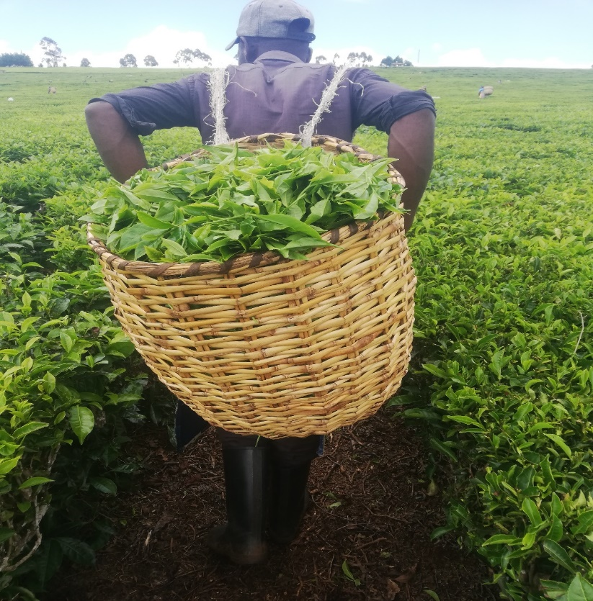

*Image 2: A worker carrying a full basket of tea leaves from the tea plantation to the tea collection point at Nandi Tea Estates, Kenya. A basketful of tea leaves weighs about 20 kilograms. Tea workers walk for about half a kilometer from the tea plantation to the collection point with the bags strapped on their backs.*

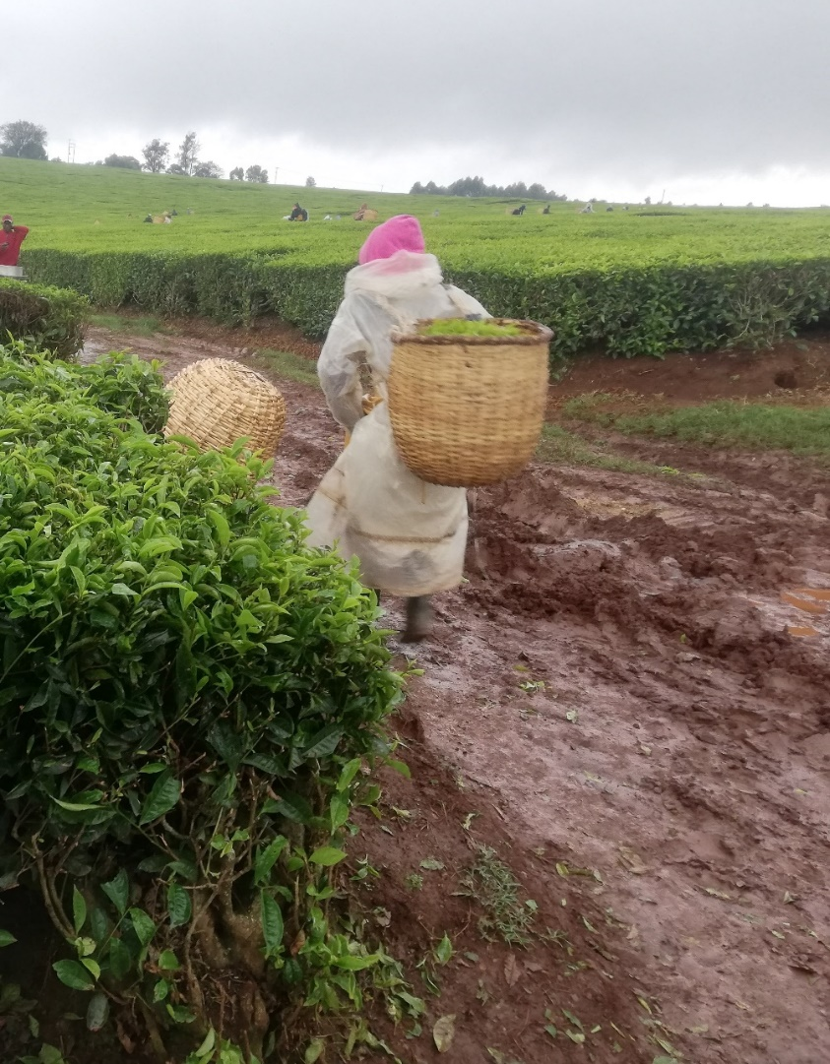

*Image 3: A worker in Nandi Tea working while it was drizzling. During peak season the harvest is high hence the workers stay up in the plantation despite unfavorable weather conditions such as rains.*

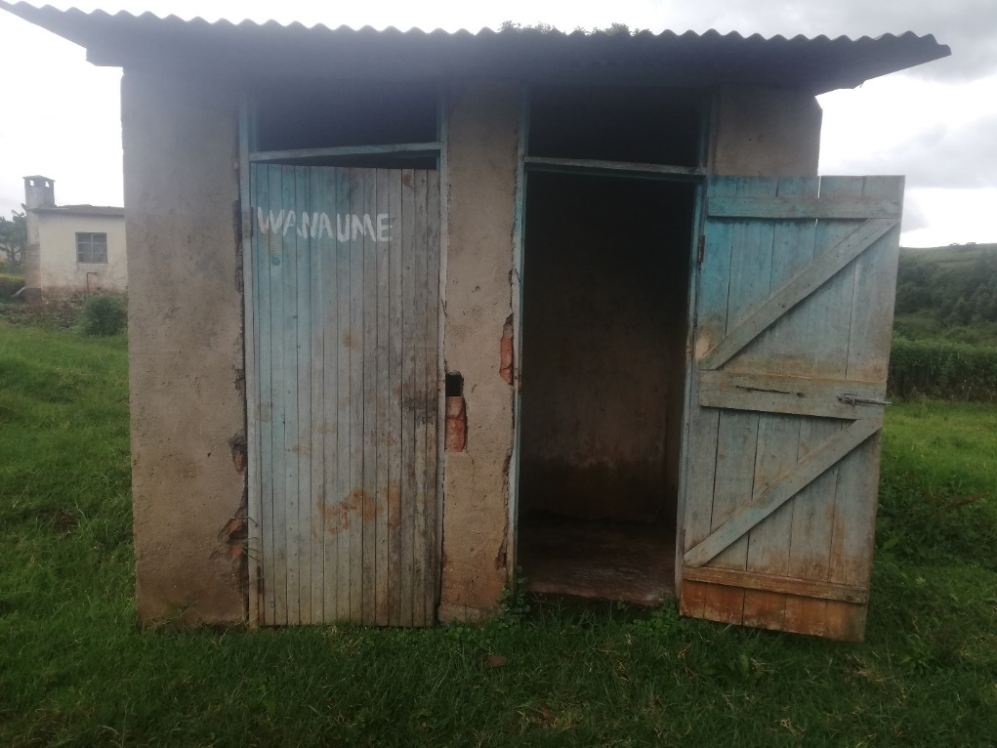

*Image 4: The image illustrates the sanitation facility used by the workers at the Nandi Tea Estates. On average, about 30 people share one sanitation facility.*

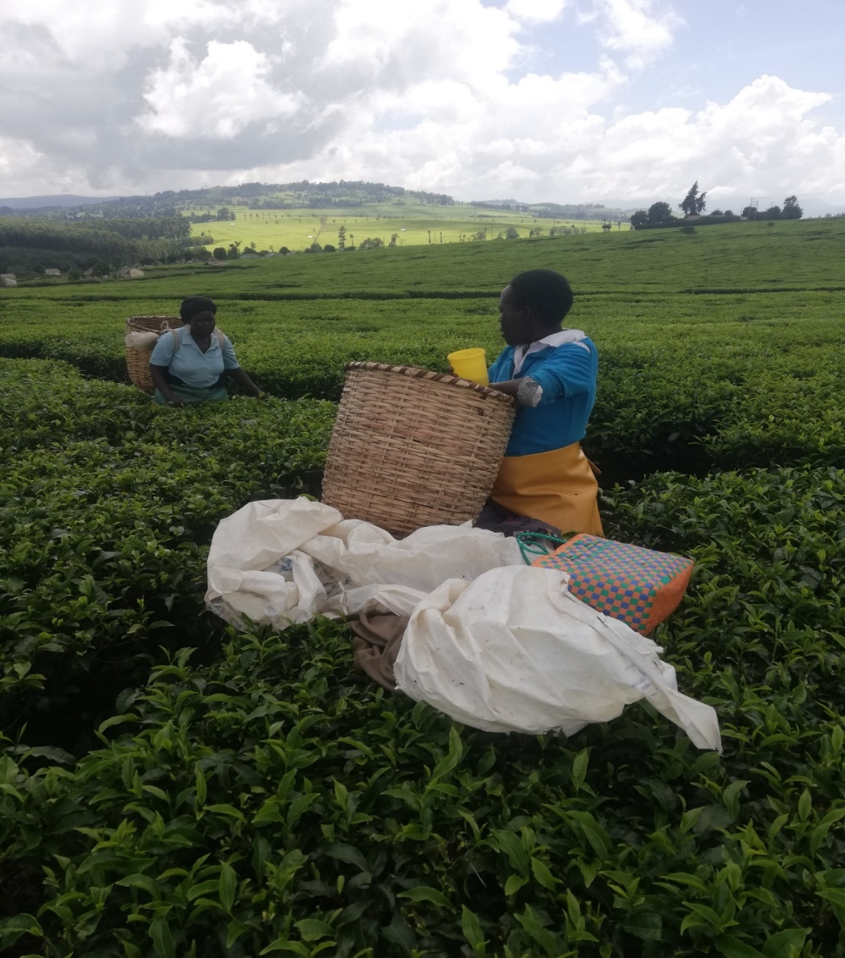

*Image 5: A worker taking lunch at the tea plantation. During peak seasons, the workers do not have lunch breaks but are provided with porridge for lunch.*

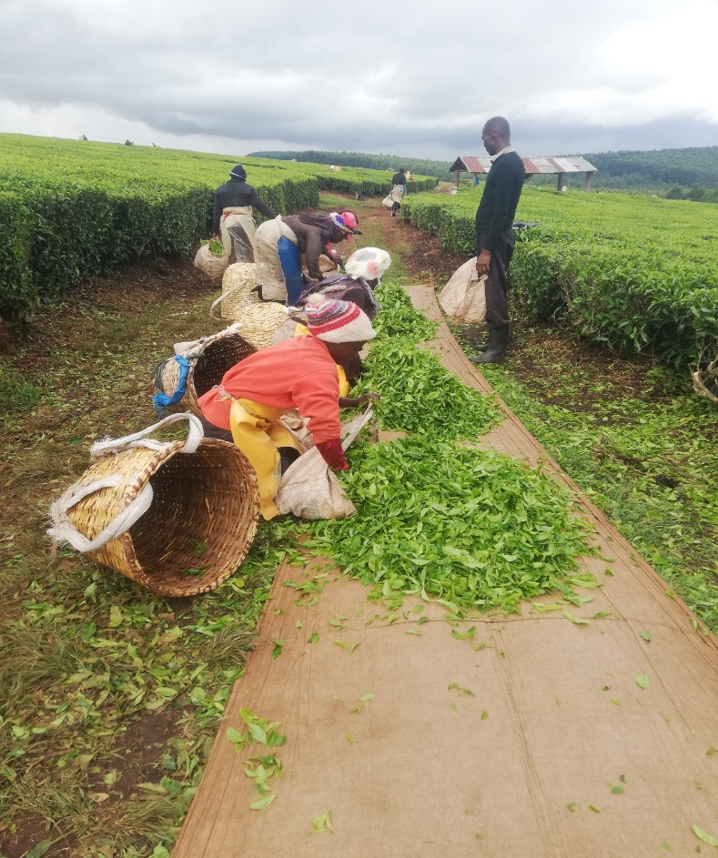

*Image 6: Leaf inspection process at Nandi Tea Estate. Workers are expected to pluck at leasts 45kgs of tea a day in order to get the day’s pay. The tea is inspected thoroughly before being weighed. After approval, the tea is taken to the factory for processing.*